The structures of an IO table and of internationally-linked IO tables
An IO table provides data on the interactions between suppliers (rows) and users (columns) of: (i) domestically-produced and consumed intermediates (raw materials, industrial parts and components, and services), (ii) domestically-produced and consumed final goods, in private final consumption, in Government final consumption, or in GFCF; (iii) domestically-produced and exported final goods, and; (iv) externally-produced imported intermediates.
In fact, this matrix is a supply and use table of national production, as referred to in Eurostat (2008), and not a supply and use table of total flows in the economy, since the data does not inform about imports of final goods, including those re-exported with no value-added in the domestic economy. A supply and use table of total flows would also present an additional row for imports of final goods. However, this missing information is not relevant for the purpose of assessing the participation of national production in GVCs.
The basic structure of an IO table is presented below in Figure 1.
Figure 1 - The basic structure of an IO Table
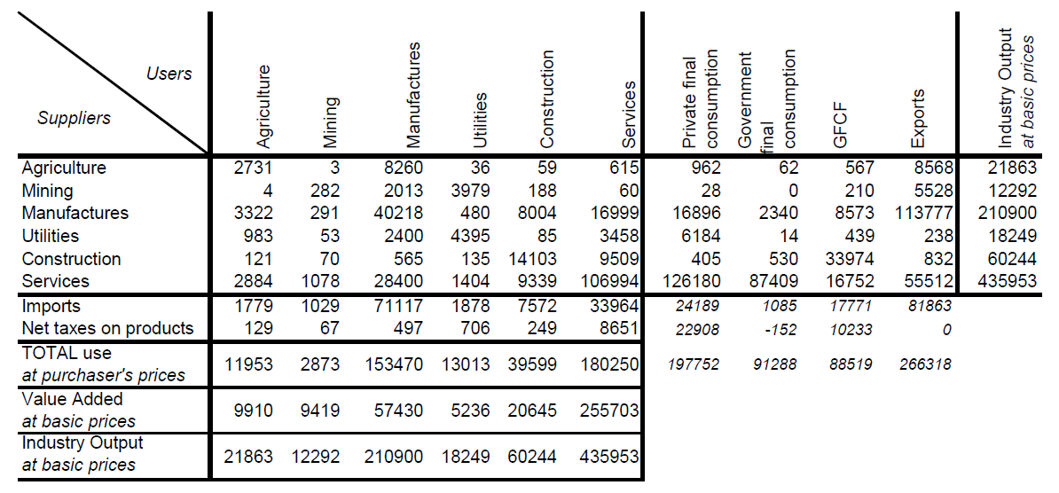
3
2
1
Source: Wixted et al (2006).
In Figure 1, rows show how a given sector of activity, for example say agriculture (Row 1), supply (i) the production of other sectors (3 units as inputs in the mining sector, 8,260 units as inputs in the manufactures sector, 36 units as inputs in the utilities sector, 59 units as inputs in the construction sector, and 615 units as inputs in the services sector); (ii) the production in the same sector (i.e. 2,731 units); (iii) the final consumption in the country (962 units); (iv) the government final consumption in the country (62 units); (v) the GFCF in the country (567 units), and; (vi) exports (8,568). Columns show how the production of a given sector of activity, for example say agriculture (Column 1) disaggregate in terms of: (i) inputs from other sectors of activity (i.e., 4 units from mining, 3,322 units from manufactures, 983 units from utilities, 121 units from construction, and 2,884 units from services); (ii) inputs from the same sector (2,731 units from agriculture); (iii) imported inputs (1,779 units); (iv) taxes on products (129 units), and; (v) value added in the sector, at basic prices, representing the sum of wages and salaries (remuneration of labour) plus gross operating surplus (remuneration of capital) (9,910 units).
The central section of the matrix (Box#1) shows the intermediates’ matrix, which provides data about the interactions between domestic suppliers and domestic users of domestically-produced raw materials, industrial components and services. This is by definition, a squared matrix, and the values recorded can be either at basic or at purchaser’s prices. In Box#3, one can observe the total imported inputs. The supplies of goods that are not consumed by domestic industries are represented in Box#2.
The international linkage between the IO tables of several countries can be observed in Figure 2 below. This extended matrix just builds on the matrix observed in Figure 1 above, by disaggregating the column called ‘Exports’ in several submatrices, which present, for each one of the other countries in the sample and the remaining Rest of the World (RoW) as a whole, information about how the goods and services supplied have been used in those countries as inputs, per sector; as private final consumption; as Government final consumption; and as GFCF. For example, Figure 1 above shows that agriculture supplies foreign users with 8,568 units. Additionally, Figure 2 shows how those 8,568 units disaggregate per country and per final use (e.g., that 343 units were used as inputs in the production of manufactured goods of country B, or that 1,285 units were used as private final consumption in country B).

Figure 2 - The basic structure of an internationally linked IO Table (for three regions; country A, country B and Rest of the World)
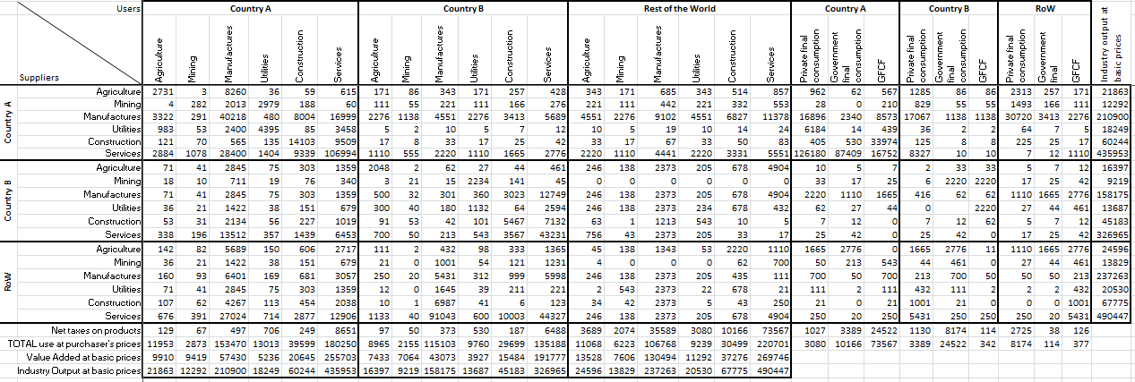
Source: Authors, based on Timmer et al. (2012a).
Analogously, this extended matrix also builds on the matrix observed in Figure 2 above, by disaggregating the row called “Imports” into several submatrices which present for each one of the other countries in the sample and the remaining RoW as a whole, information about how the domestic production of goods and services are supplied with inputs by each one of the other countries, per sector. For instance, in Figure 1 above, the production of the agriculture sector was supplied by inputs produced abroad amounting to 1,779 units. Figure 2, additionally, shows that amount disaggregated per country and per sector (e.g., 71 units of inputs were originated in the manufacture sector of Country B, or that 142 units of inputs were originated in the agriculture sector of countries not covered in the sample).

The basic price is the amount receivable by the producer exclusive of taxes payable on products and inclusive of subsidies receivable on products (the equivalent for imported products is the c.i.f. – the cost, insurance, and freight, that is to say, the value at the border of the importing country). The purchaser price is the amount payable by the purchaser (which includes trade margins realised by wholesalers and retailers – which is, by definition, their output - as well as transport margins - that is to say, any transport charges paid separately by the purchaser - and also non-deductible value-added tax (definitions by the Data Helpdesk of the World Bank, in https://datahelpdesk.worldbank.org/knowledgebase/articles/114947-what-is-the-difference-between-purchaser-prices-p).
For additional information about how these internationally linked IO matrices are built, see Yamano & Ahmad (2006), Wixted et al. (2006), and Timmer et al. (2012).

